Pollution Control Monitors – Multi-Agent Simulation System:

1. Objective
To design a multi-agent pollution monitoring and mitigation system where sensors placed on a grid detect pollution, communicate alerts, and coordinate mitigation.
The goal is to reduce pollution levels over time and visualize improvements.

2. Problem Definition
Urban cities suffer from fluctuating pollution due to vehicles, factories, fires, and environmental changes.
A centralized pollution monitoring system is often too slow to react.
Therefore, we need:
- A distributed sensor network
- Local intelligence to detect and respond
- A mechanism to reduce pollution automatically when thresholds are exceeded
- A way to observe the overall effect on pollution levels
This simulation replicates those behaviors using:
- A grid of pollution-monitor agents
- Diffusion-based pollution spread
- Threshold-based alerts
- Local mitigation actions
Output required → Graph of Pollution Levels Over Time

3. Environment Selection
We use a 2D grid environment:
- Each cell = one pollution monitor agent
- Agents hold a pollution value (AQI)
- Pollution spreads to neighbors (diffusion model)
- Mitigation reduces pollution in high-intensity areas
This environment is chosen because:
- Air pollution behaves spatially
- Grid models are efficient for simulation
- Easy to visualize and manipulate
- Agents can interact locally

4. Agent Architecture Design
We define three agent types:

1. Pollution Monitor Agent
- Senses pollution in its grid cell
- Compares AQI with a threshold
- Triggers alert
- Requests mitigation

2. Pollution Source Agent
- Represents factories/vehicles emitting pollution
- Sets high initial AQI in selected spots

3. Mitigation Agent
- Activated automatically when any cell exceeds threshold
- Applies pollution reduction (mitigation_power)
- Operates in a decentralized, cell-based manner
Each agent operates independently but interacts through the environment.

5. Agent Interaction Diagram:
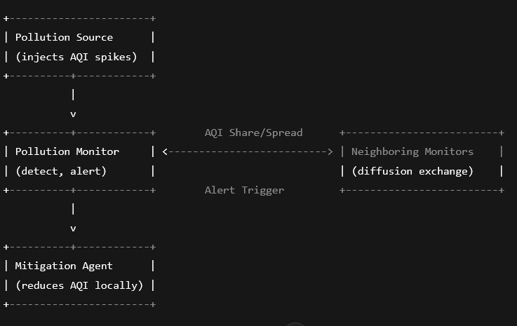
The flow is:
- Pollution spikes
- Monitors sense & alert
- Mitigation agent reduces AQI
- Neighbor monitors balance levels

6. Routing Logic Plan
The system uses distributed alert logic:

1. Pollution Spread
At every timestep:
- AQI diffuses to neighbors using averaging
- Adds realism to environmental spread

2. Mitigation Logic
For any grid cell:
if AQI > threshold:
apply mitigation_power reduction

3. Natural Decay
After mitigation, AQI naturally reduces by a small amount.
This creates a realistic pollution timeline.

7. Python Code (Working Example)
import streamlit as st
import numpy as np
import matplotlib.pyplot as plt
from io import BytesIO

st.title("Pollution Control Monitors – Interactive Simulation")

# Grid size
N = st.slider("Grid Size (NxN)", 5, 30, 10)
steps = st.slider("Simulation Steps", 10, 200, 50)
threshold = st.slider("Alert Threshold (AQI)", 50, 300, 150)
mitigation_power = st.slider("Mitigation Power", 1, 50, 20)

# Initialize pollution grid
np.random.seed(42)
pollution = np.random.randint(20, 80, (N, N))

# Pollution sources
num_sources = st.slider("Number of Pollution Sources", 1, 10, 2)
sources = [(np.random.randint(0, N), np.random.randint(0, N)) for _ in range(num_sources)]
for s in sources:
pollution[s] = 200

avg_pollution_over_time = []

def spread(poll):
new = poll.copy()
for i in range(N):
for j in range(N):
neigh = []
for dx, dy in [(-1,0),(1,0),(0,-1),(0,1)]:
x, y = i + dx, j + dy
if 0 <= x < N and 0 <= y < N:
neigh.append(poll[x][y])
if neigh:
new[i][j] = poll[i][j] + 0.1*(np.mean(neigh) - poll[i][j])
return new

def mitigation(poll):
high = np.argwhere(poll > threshold)
for x, y in high:
poll[x][y] -= mitigation_power
return poll

# Simulation
for t in range(steps):
pollution = spread(pollution)
pollution = mitigation(pollution)
pollution -= 1 # natural decay
pollution = np.clip(pollution, 0, None)
avg_pollution_over_time.append(np.mean(pollution))

# Plotting
fig, ax = plt.subplots()
ax.plot(avg_pollution_over_time)
ax.set_xlabel("Time Step")
ax.set_ylabel("Average AQI")
ax.set_title("Pollution Level Over Time")

# Display graph in Streamlit
st.pyplot(fig)

st.subheader("Final Pollution Grid")
st.write(pollution)

8. Testing Procedure
To validate the system:

Test 1 — Pollution Spread
- Start with a single pollution source
- Check if AQI gradually spreads outward

Test 2 — Alert Trigger
- Set threshold low
- Ensure immediate activation of mitigation agents

Test 3 — Mitigation Effectiveness
- Increase mitigation power
- Observe graph drop more sharply

Test 4 — Scalability
- Increase grid size to 30×30
- Ensure simulation remains stable

Test 5 — Multiple Sources
- Add 5–10 sources
- Confirm the system responds to all hotspots

9. Optimization & Collaboration Tuning
Possible improvements:

Adaptive Mitigation
- Agents collaborate by increasing mitigation if neighbors also exceed threshold

Cluster-Based Mitigation
- Nearby alerts form a “pollution cluster”
- Shared mitigation agents handle the entire cluster

Dynamic Thresholds
- Threshold changes based on area historical pollution

Faster Diffusion Calculation
Using NumPy vectorization accelerates computation drastically.

10. Final Output: Pollution Level Reduction
The system produces:

📈 Pollution Level (AQI) vs Time Graph
Shows:
- Initial pollution spike
- Spread across grid
- Agent-triggered mitigation
- Gradual decline of average AQI
This visually demonstrates:
“Distributed mitigation reduces pollution significantly over time.”

11. Conclusion
This multi-agent Pollution Control Monitor system shows how a distributed network of intelligent sensors can:
- Detect pollution hotspots
- Trigger localized mitigation
- Collaborate through diffusion and alerts
- Stabilize the environment autonomously
The interactive simulator helps users understand:
- Environmental behavior
- Agent-based system design
- Effects of mitigation strategies
This model can evolve toward smart city air-quality systems, IoT deployments, or environmental research tools.

